Condition based on work log information

This script will return True or False based on the log type to be used as a custom condition via Conditional Expression Manager

Scripting with Maximo References:
https://www.ibm.com/developerworks/community/blogs/a9ba1efe-b731-4317-9724-a181d6155e3a/entry/scripting_with_maximo6?lang=en
https://www.ibm.com/developerworks/community/forums/ajax/download/77777777-0000-0000-0000-000014772567/b8ec7d85-6a8d-4e25-
bb89-d729c3322406/attachment_14772567_Scripting_with_Maximo.pdf

System Configuration > Platform Configuration > Automation Scripts
Action > Create a Script with an Object Launch Point

Automation Script Tab
Script Source:
if logtype == 'WORK':
evalresult=True
else:
evalresult=False

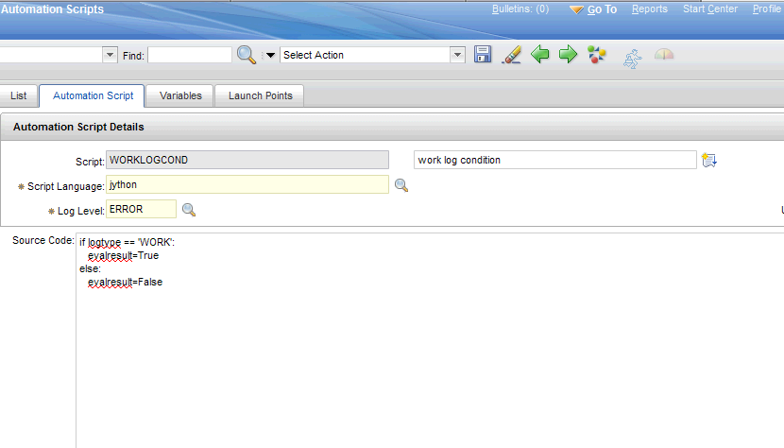

Variables Tab

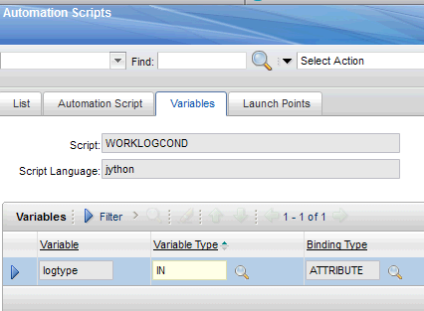

Launch Points Tab

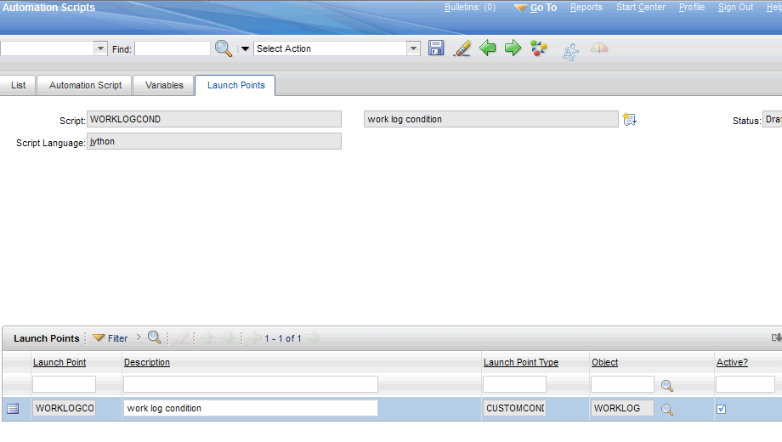

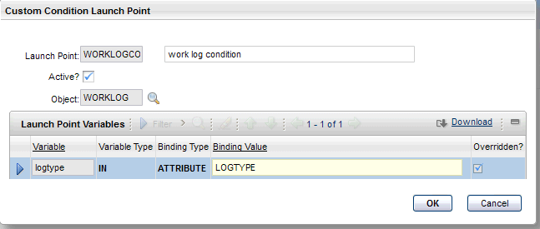

Now create the condition:

Administration > Conditional Expression Manager
New Row
